E N G L I S H C O R N E R M E N U
Learning English through Discussion

The Storms of Life

Today’s lesson is about storms, floods and a wise man.

HOT TOPICS
1. Work out the meaning of the weather idioms in the following discussion questions (good luck!)
a. What were you doing on Saturday night when it was bucketing down?
b. In your country when does it usually rain cats and dogs?

2. A typhoon hit Tokyo on Monday night. Have you ever experienced a hurricane, typhoon, tornado, earthquake or flood? Share your experiences.

THE STORY - Matthew 7:21-29 (DB)
Today’s story is a parable told by Jesus. A parable is a story that has a deeper meaning. We can learn important truths from parables told by Jesus.

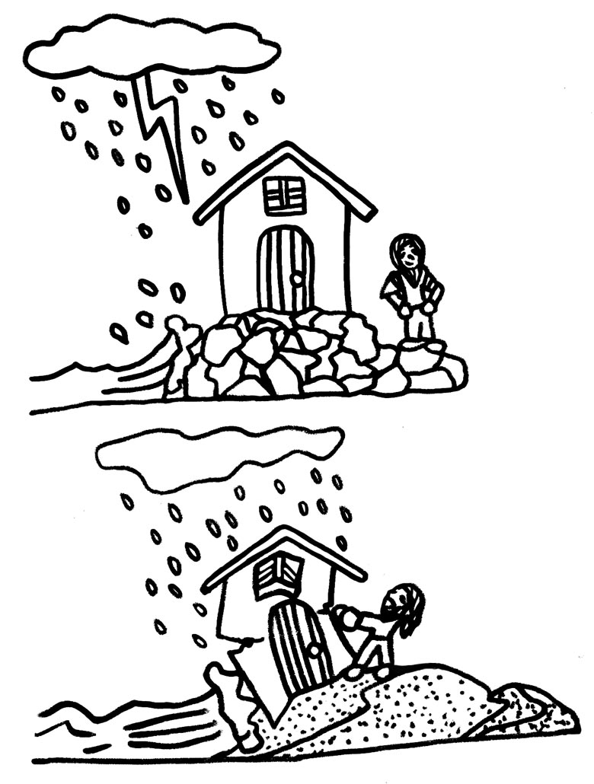

Choose three people to read the story: Voice 1, Voice 2 and Narrator.

Voice 1 Anyone who hears these words of mine, and obeys them is like a wise man who built his house on rock.

Voice 2 The rain poured down, the rivers flooded and the wind blew hard against the house. But it did not fall because it was built on rock.

Voice 1 But anyone who hears these words of mine and does not obey them is like a foolish man who built his house on sand.

Voice 2 The rain poured down, the rivers overflowed, the wind blew hard against that house, and it fell. And what a terrible fall it was!

Narrator When Jesus finished saying these things, the crowd was amazed at the way he taught. He wasn’t like the religious teachers – Jesus taught with authority.

DISCUSSION

1. Divide into pairs. Student A: draw the foolish man’s house. Student B: draw the wise man’s house. Then explain the story together. What is the meaning of the house?

2. In pairs discuss what Jesus was trying to teach. What is the meaning of this story?

3. When you visit another country, away from family and friends, you can be faced with many different choices and experiences (good and bad). Your ‘house’ (life) can be shaken.
a. How do you handle the storms in your life?
b. What foundation (base) is your life built upon?
e.g. family, friends, career, education, culture, success, religion (beliefs), happiness, luck, destiny, other…

VOCABULARY

Obeys these words of mine: To follow or do what Jesus says to do.
Wise: A wise person is able to use their knowledge and experience to make good decisions.
Foolish: Opposite of wise.
The rain poured down: to rain really heavily, producing lots of water. Crowd: Many people.
Jesus taught with authority: He taught with confidence and people respected and admired what he said.

